STRUCTURE PLAN MANNER AND FORM
FORMAT AND CONTENT OF A STRUCTURE PLAN
In compliance with Schedule 2, clause 16(1)(a) to (c) of the Regulations, the WAPC expects structure plans to be prepared in the following manner and form, and include the information referred to (where relevant).
A structure plan has three main components: the Executive Summary, Part One and Part Two. It is prepared based on the following outline:
Cover page
Approval page (to be inserted by the WAPC upon approval)
Table of amendments
Executive summary
Table of contents
Part One: Implementation
Part Two: Explanatory section - Technical appendices
Title | Format & Content
Note: The format and content outlined in this table is broad so that it can be adjusted as required to suit the locality, purpose, and scope of the plan.
Approval page | To be inserted by the WAPC upon approval
Table of Amendments | Each time a structure plan is amended, the amendment is recorded in a Table at the front of the structure plan.  Amend No: Summary (in bullet points) Date approved by the WAPC  1  2  ...  Note: Previous versions of the structure plan are to remain available on the WA government website.
Executive Summary | - State the vision of the plan.  - Outline the plan's design rationale and the key planning outcomes to be delivered, including targets and key figures.  - Provide an Executive Summary Table (refer to Appendix 5).

PART ONE – IMPLEMENTATION
Part One is the implementation component of the structure plan and includes the structure plan map. It contains the necessary information, requirements, and controls to be applied when assessing land use, subdivision, and development applications in the structure plan area.
Part One should not include any explanations, discussions, supporting information, or design principles. Objectives, if included in Part One, are to be clear, concise, and appropriate to the level of planning and design being undertaken.
Title | Format & Content
1. Structure plan area and operation | - Describe the area to which the structure plan applies (application area outlined on the structure plan map).  - State that:  "The plan is in effect from the date stated on the cover [date decision letter is distributed to the applicant] and for a period of 10 years [or for any other period approved by the WAPC]."  - Identify other instruments informing the structure plan's implementation (e.g., local planning scheme).
2. Purpose | Outline the structure plan purpose and key objectives.
3. Staging | Describe how subdivision and/or development is intended to proceed, and:  - Identify subdivision/development stages (short/medium/long term) as they relate to major infrastructure becoming available or other triggers.  - For precinct structure plans, identify agency responsibilities or development incentives (refer to SPP 7.2).
4. Subdivision and development requirements | Identify the requirements for subdivision/development:  Note: For precinct structure plans, information under this section can be grouped and presented per precinct.
4.1 Land use zones and reserves | Refer to the structure plan map:  "Plan 1 designates proposed zones/precincts and reserves in the structure plan area."  Provide information and guidance to support implementation together with what is shown on the structure plan map  4.1.1 Zones/Precincts:  - Provide information about the zones or precincts depicted on the structure plan map. The zones should be consistent with the scheme.  - For precincts, include objectives of the precinct and preferred land uses.  4.1.2 Road reserves:  - Set out specifications for the movement network (including hierarchy of roads and reserve widths).  - Include graphics and/or cross-sections where necessary for implementation. Cross-sections can dictate lanes, paths, car parking, and street trees (as applicable).  4.1.3 Public Open Space:  - Detail the extent, type, and function of public open spaces (existing and proposed) as shown on the structure plan map.  - For proposed public open space, provide a public open space schedule including the percentage used for stormwater drainage (identify drainage areas on the structure plan map).  4.1.4 Other reserves:  - Detail arrangements for other public reserves (foreshore, conservation, regional open space, school sites, utilities etc.)
4.2 Density and development | Refer to structure plan map:  "Plan 1 designates the R-Codes applicable to subdivision and development in the structure plan area"  Outline the relevant considerations for subdivision and/or development (as applicable):  4.2.1 Density and R-Codes:  - Detail density distribution and the relationship with the R-Codes, depicted on the structure plan map.  4.2.2 Locational criteria: (only applicable to standard structure plans)  - If R-Codes ranges are shown on the structure plan map, list the criteria for allocating R-Codes at the time of subdivision (refer to Clause 4.7.1).  - Include paragraph for the preparation of an R-Codes plan under clause 5 'Additional details' of the Manner and Form (below).  "An R-Codes plan is to be submitted at the time of subdivision for the entire structure plan area. The plan will allocate R-Codes for proposed street-blocks/lots (as the case requires). Once approved by the WAPC, the R-Codes plan forms part of the structure plan."  4.2.3 Development provisions: (only applicable to precinct structure plans)  - Set-out development controls for built form (height, setbacks, building separation, orientation, plot ratio, etc.), and include graphic concepts where desirable.  - Include concepts for public realm design (public open space, streetscapes, and pedestrian thoroughfares).  4.2.4 Development layout:  - Where commercial, mixed use, education or community sites are proposed, provide the intended development layout (position of buildings) and parking arrangements.  4.2.5 Local Development Plans (LDP): (only applicable to standard structure plans and in limited situations)  - Where an LDP is proposed, specify the matters and the outcomes the LDP is set out to deliver (LDP area(s) to be identified on the structure plan map).  4.2.6 Interface with adjoining areas:  - Outline arrangements for an appropriate land use transition or development interface with adjoining land (interface areas to be identified on the structure plan map).  4.2.7 Heritage:  - Outline mechanisms to protect heritage features (heritage features to be identified on the structure plan map).

4.3 Other requirements | Outline other necessary arrangements for land use, subdivision, and/or development, including:  4.3.1 Bushfire protection:  - For bushfire prone areas, identify the need for a site specific bushfire management plan at the time of subdivision.  4.3.2 Infrastructure arrangements, including:  - Road and intersection upgrades where required (identified on the structure plan map).  - Utility upgrades to service the structure plan area.  4.3.3 Development contributions:  - Describe infrastructure items, including community infrastructure, and funding arrangements (contributions) in accordance with the local planning scheme.  - If the structure plan considers funding mechanism(s) other than a contribution plan, identify these arrangements and how they are to be implemented.  4.3.4 Development incentives for community benefit: (only applicable to precinct structure plans)  - Define development incentives in exchange for community benefits in nominated areas (including the criteria based on which incentives are applied).  4.3.5 Protection or management of environmental or landscape features:  - Including foreshore management, protection, and relocation of flora and fauna, etc.  4.3.6 Water resource management:  - Demonstrate feasibility of the water management systems and strategies.
5. Additional details | List additional detail for subdivision/development that is to be submitted later:  5.1 Information to be submitted with an application:  - List the information to be submitted with an application in a table, outlining the type of study/plan, what matters the plan/study will address and who should be consulted (LG or agency) at the time.  Additional Information / purpose Approval stage Responsible agency (consultation required)  5.2 Studies to be required under condition of subdivision/development approval  - Identify studies/plan(s), to be required under conditions of subdivision/development approval.  Conditions of subdivision approval Responsible agency

STRUCTURE PLAN MAP
Title | Format & Content
INTENT | The structure plan map is contained in Part One and is to show the spatial information necessary for the implementation of the structure plan.  It is desirable that for each of the attributes shown on the structure plan map, Part One includes a section with textual guidance for implementation.
CONTENT | As a general guide, a structure plan map - or a series of maps - is to show:  - structure plan area boundary;  - existing lot layout (where fragmented landownership);  - protected environmental or heritage features;  - landscape features or vegetation proposed to be retained;  - proposed land use zones and/or precincts and public reserves;  - proposed commercial/landmark sites;  - existing/proposed education and community sites;  - proposed urban structure comprising blocks and streets;  - hierarchy of streets (including transit corridors and pedestrian, bicycle, and public transport networks);  - open space network including type of open space, public open space, and drainage function;  - proposed R-Codes for residential/mixed use zones or precincts;  - interface areas that link to a design response in Part One;  - existing/proposed road intersections that require upgrading or a specified treatment;  - sites where a LDP is proposed/required;  - separation areas/buffers (from/to sensitive land uses); and  - proposed staging of subdivision/development.  Only if a key component to implementation:  - proposed lot layout (e.g., for precinct plans or rural living, not for residential/greenfield type of structure plans); or  - building exclusion zones.
DIGITAL FORMAT | The structure plan map should also be submitted in a digital format consistent with the WAPC’s Digital Data and Mapping Standards. Refer to Planning and Development (Local Planning Schemes) Regulations 2015 and Appendix 7 for further information.

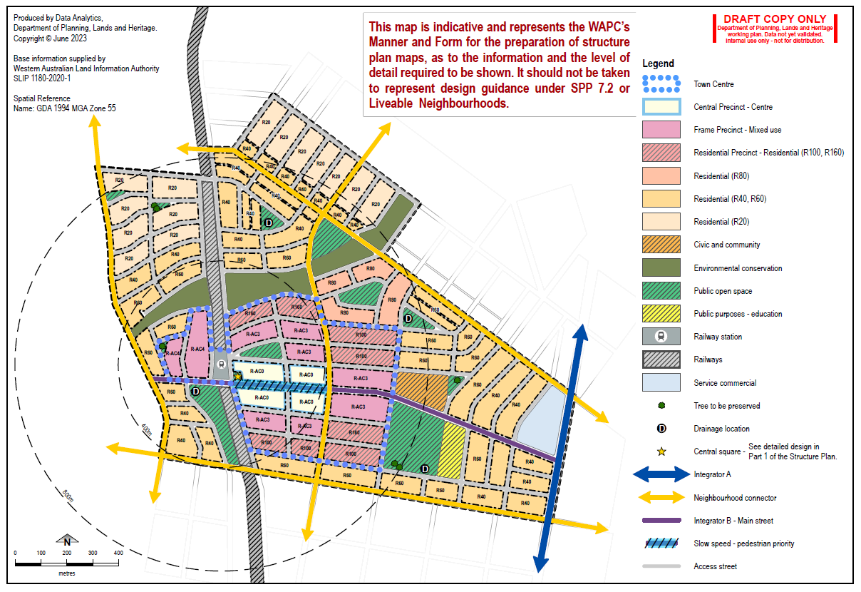

PART TWO - EXPLANATORY SECTION
Part Two is the explanatory component of the structure plan that contains the:
- background information, design process, and rationale for the making of the structure plan;
- technical appendices comprising the detailed studies and investigations for certain aspects of the structure plan; and
- supporting plans and figures.
Part Two makes recommendations for the implementation measures in Part One. The following headings can be used (as appropriate).
Title | Format & Content
1. Introduction and purpose  Refer to Clause 4.4 | Define the purpose of the plan and matters to be addressed (as set out by the planning strategy or strategic plan) - Set targets
2. Site and context analysis  Refer to Appendix 2 | Identify the context as per Appendix 2 - Site and Context Analysis:  - Physical context (including environmental considerations).  - Community context (including social infrastructure, economy, and culture).  - Planning and governance context (strategic and statutory planning framework, utilities, existing plans, and projects).
3. Opportunities and constraints analysis  (Response to context)  Refer to Clause 4.4 | - Identify opportunities and constraints (strengths, weaknesses, opportunities, and threats analysis).  - Refer to findings of technical reports and studies undertaken so far and their recommendations.  - Identify design objectives/considerations.  - Prepare initial concept layouts.  - For precinct structure plans, carry out a design review (where a Design Review Panel is available).  Note: Proponent to seek pre-lodgement advice at this stage.
4. Stakeholder and community engagement  Refer to Clause 4.5 | Describe the engagement process and provide a summary of outcomes from the:  - community consultation (where applicable); and  - pre-lodgement consultation with the LG/WAPC/other agencies.  Indicate how the proposal has/will respond to the feedback received.  Note: Refer to the Guide to Best Practice Planning Engagement in Western Australia.
5. Design response  Refer to Clause 4.4 | - Refine the structure plan vision/purpose and objectives.  - Formulate a design response and identify design outcomes for each of the below policy elements as per Liveable Neighbourhoods or SPP 7.2, as the case requires.  - Define the rationale for the designation of R-Codes to guide subdivision and development in residential areas.  - Demonstrate the adequacy of public open space in quality (function), quantity, distribution, and accessibility in meeting community needs.  - The design should respond to the bushfire risk presented by the surrounding landscape, particularly along interfaces against bushfire hazards.
- Produce an overall concept plan (masterplan) or precinct design plan for the structure plan area.
- For precinct structure plans, carry out a design review (where a Design Review Panel is available) and include the outcomes.
- Make recommendations for implementation in Part One.
 | State Planning Policy 7.2. - Design Elements | Liveable Neighbourhoods – Elements
1 | Urban ecology | Community Design
2 | Urban structure | Movement Network
3 | Public realm | Lot layout
4 | Movement | Public parkland
5 | Land use | Urban Water Management
6 | Built form | Utilities
7 | - | Activity centres and employment
8 | - | Schools
Note: proponent to seek pre-lodgement advice at this stage
TECHNICAL APPENDICES
The Appendices include the detailed technical studies and investigations undertaken to inform aspects of the structure plan. Each technical appendix in the structure plan should include a 'Recommendations' section to:
(a) inform the design rationale of the structure plan;
(b) determine implementation measures in Part One; and
(c) specify subsequent plans or studies to be prepared at the subdivision/development stage.
Title | Format & Content
Examples of technical appendices  (Include a Technical Appendices Index) | - Environmental assessment and management strategy
 | - Local water management report
 | - Site and soil evaluation
 | - Local biodiversity strategy
 | - Landscape and public open space masterplan
 | - Ethnographic and Aboriginal heritage report
 | - Transport and access strategy, including a Transport Impact Assessment
 | - Bushfire Hazard Level assessment or Bushfire Attack Level contour map and accompanying Bushfire Management Plan
 | - Noise impact assessment
 | - Local economic, retail and employment strategy
 | - Local community development strategy
 | - Community benefits framework under SPP 7.2 (for activity centres/precinct structure plans)
 | - Local infrastructure and servicing strategy
 | - Parking (management) plan (for activity centres/precinct structure plans and other non-residential areas)
 | - Needs assessment under SPP 4.2 (for activity centres/precinct structure plans)
 | - Engagement strategy and outcomes report
 | - Flora Management Plan
 | - Coastal Hazard Risk Management and Adaptation Planning
Precinct Plan Outputs
Additional reports and studies may be required in accordance with the Precinct Plan Outputs specified in SPP 7.2. The Precinct Plan Outputs may comprise technical reports or studies; form an outcome of the structure plan design response (e.g. tree management strategy); and/or inform the implementation of the structure plan under Part One (e.g. streetscape cross-sections, design guidelines, etc).

The cover page states the date the plan comes into effect, being the day that the structure plan is approved by the WAPC.
The approval page is not to be removed or updated by subsequent amendments.
This is state whether the preparation of the plan has involved stakeholder and community to formulate the vision.
This is not an exhaustive list of all possible technical appendices. Additional reports and studies may be required for structure plans, to address site specific matters.
An environmental management plan may be required to identify and protect environmental values, including flora and wildlife to be retained within the structure plan area. The relocation of wildlife (including kangaroos) from greenfield areas as a result of the land development process is a separate matter that should be considered as early as possible, with implementation measures to be set out for each step in the process: - At the re-zoning stage (Metropolitan Region Scheme Rural to Urban and/or amendment of a local planning scheme) landowners/developers should start considering appropriate measures for relocating fauna before removing vegetation or disturbing the habitat. Such measures may require coordination with an adjoining local government area. - Prior to or at the structure plan stage, the landowner/developer should prepare a management plan, to address options and stages for relocation of wildlife, in consultation with the responsible local government. The management plan should also identify the type of licencing required to be obtained by the Department of Biodiversity, Conservation and Attractions to this effect. It is important that landowners/developers are proactive in preparing the plan well ahead of the land development stage, as identified measures may require a staged implementation over a long period. - Measures and actions identified by a management plan should be implemented and complete prior to subdivision works or bulk earthworks. As such, the relevant requirements cannot form a condition of subdivision (WAPC) or development (local government) approval. - Ultimately, it is the responsibility of the landowner/developer to take the necessary actions identified by the agreed management plan, in parallel to the respective planning stages.

